GENERAL API – ACCESS PROCEDURE

Steps to provide credentials and access token to retrieve information from adrenalin API.

Step1: Call Token Generation API:
https://mpulseuat.indusind.com/CloudAPI/Adrenalintoken

Request Parameters:
- username: INDUSNDUAT

- Password: Bs5dz89xtGuXGcgNwdjsn+EfZuqEYfkgN1j9VqYKdk1+KraD+WgHRM/I02doQW9B0bNJ9pBwZ2bIhXTrNJE8fpTkCJV5fyzRo23oKs13kz2e2RSvzMzvoiRJyZJPe2SjDQ/58PH3gsnSx/QEBHxMSUETsRN+lJJoU3OxPE+/Un8=

- grant_type: password

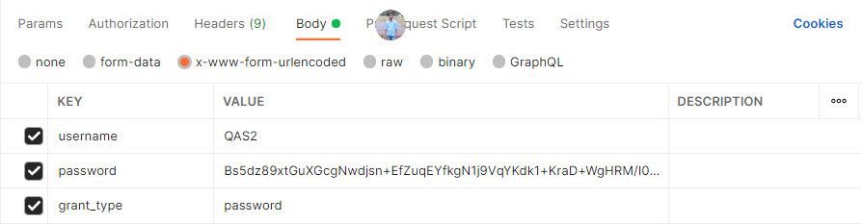

Post providing the credentials a token will be generated as shown below. The token will be valid for 30 minutes

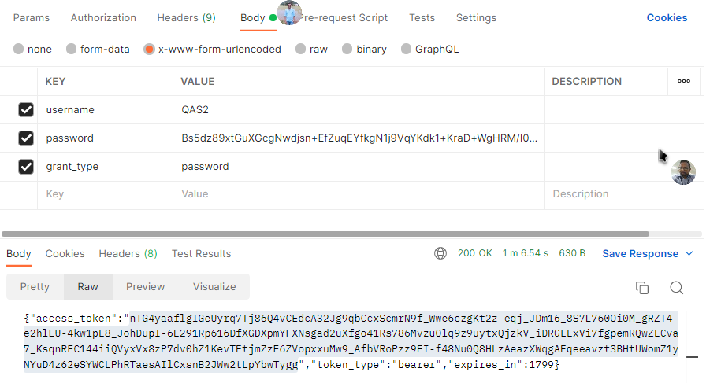

Step2: Call Getdata API for fetching basic details of Employee.

URL: https://mpulseuat.indusind.com/CloudAPI/HRdata/Getdata

Request sample:
- Param: Pass ECN here without IBL prefix
- Apino: Pass “IND_BASIC1” only
Json data:
[
{
"Param": "127188",
"Apino": "IND_BASIC1"
}
]

Provide Token and Type for authorization as shown below in Header.

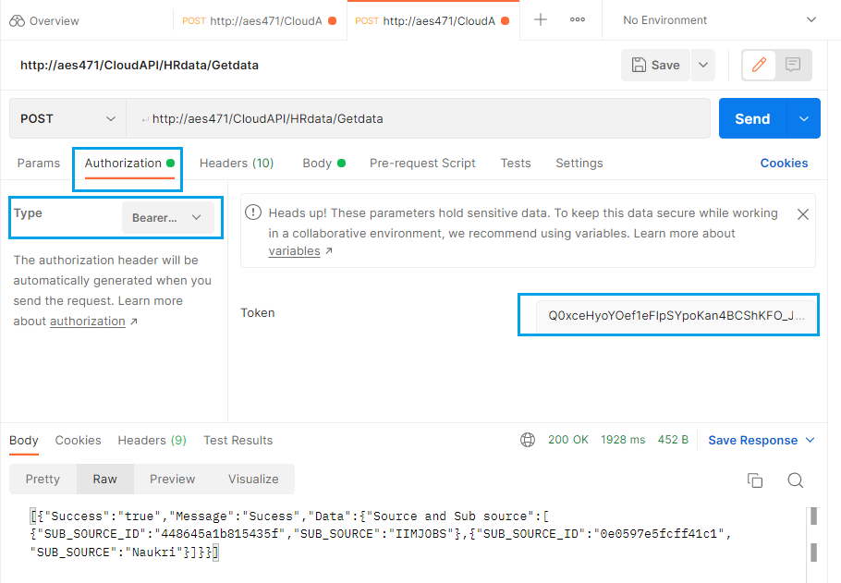

Post authorization the required output with basic details shall be visible.
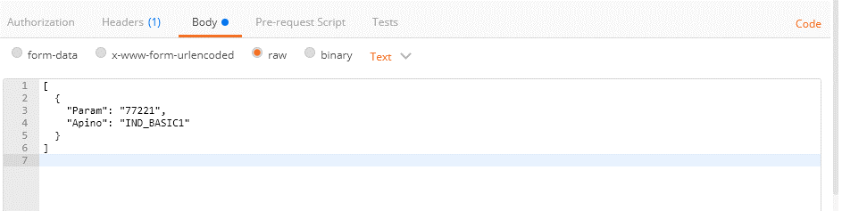

SampleResponse:
[
{
"Success": "true",
"Message": "Sucess",
"Data": {
"Employee Basic API Data": [
{
"EMPLOYEE NUMBER": "1234567",
"DOJ": "2018-01-03T00:00:00",
"Name": "First-Middle-Surname",
"GENDER": "Female",
"DEPARTMENT": "Information Technology",
"CURRENT_DESIGNATION": "Project Manager",
"BUSINESS_UNIT": "CH-Tech & CGMO-IT-CBS-SS-DC",
"OU NAME": "CH-Tech & CGMO-IT-CBS-SS-DC",
"MAIL ID": "1234567@indusind.com",
"REPORTING MANAGER": "123",
"REPORTING_MANAGER_NAME": "RM Name",
"REPORTING_MANAGER_DESIGNATION": "Project Manager",
"REPORTING_MANAGER_MAILID": "ABC123@INDUSIND.IN",
"WEEKLY OFF": "",
"FUNCTIONAL REPORTING MANAGER": "Functional Manager Name",
"COUNTRY": "India",
"EMPLOYEE STATUS": "Confirmed",
"STATUS": "Active",
"BRANCH_CODE": "",
"BRANCH ADDRESS": "",
"CURRENT_LOCATION": "Opus Office",
"CITY_NAME": "Corporate - Mumbai",
"REGION": "W1 - Maharashtra",
"ZONE": "",
"Shift Start Time": "09:15",
"GeoLocation": "",
"GeoRadius": ""
}
]
}
}
]

